##### Fancy Dairy

##### 

**Price: Rs.900/-**

Fancy Golden notebook for casual use available in different sizes.

Some of our loveliest relationships are with our Dairy. Those trusty places to scribble big ideas, little reminders and anything that inspires you throughout the day. Once you’ve chosen whether you want lined, dotted or plain paper inside, personalize your Dairy with a name, a fun title– anything you like!

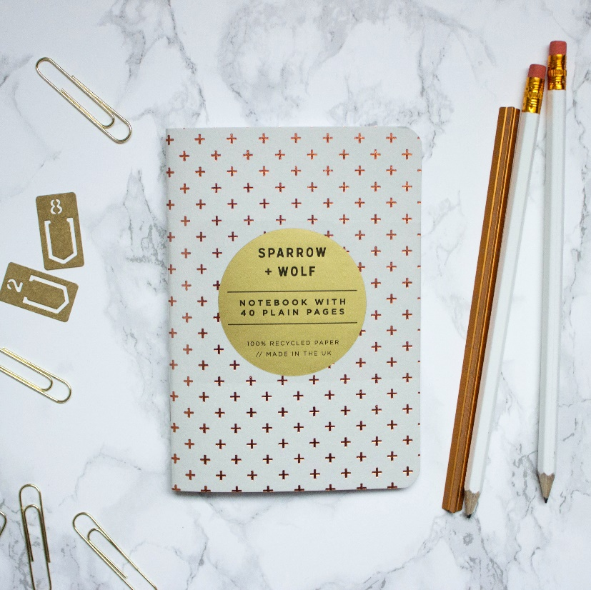

* Model Number: 20785856119
* Type: Dairy
* Promotional: No
* Style: Dotted
* Display Screen: show as the picture
* Use: Paper
* Origin: Japan
* Color: white ,blue, black.
* Size: 6.5cm x 12cm x1cm
* Type 1: dotted Dairy